User Guide
HEALTH AI Co-Creation & Innovation Platform

Project Name | HEALTH AI Co-Creation & Innovation Platform
Course | SENG384 – Software Engineering
Group No / Name | Co-Nova EG
Group Members | Ecem Tüysüz — 202228050 Gizem Fatma Kılıç — 202228028
Submission Date | 05/05/2026
Version | 1.0
Revision History
Date | Version | Change Description | Author
05-05-2026 | 1.0 | Initial version | Ecem Tüysüz — 202228050 Gizem Fatma Kılıç — 202228028

Table of Contents
Table of Contents 2
1. Introduction 3
1.1 Document Purpose 3
1.2 Target Audience 3
1.3 Platform Overview 3
1.4 System Requirements 3
2. Getting Started 3
2.1 Registration 3
2.2 Login 4
2.3 Dashboard Overview 4
3. Post Management 4
3.1 Creating a New Post 4
3.2 Post Form Fields 4
3.3 Editing a Post 4
3.4 Post Status Guide 5
3.5 Marking Partner Found 5
4. Search & Partner Discovery 5
4.1 Browsing Posts 5
4.2 Filtering Options 5
4.3 City-Based Matching 5
5. Meeting Request Process 6
5.1 Expressing Interest 6
5.2 NDA Acceptance 6
5.3 Proposing & Accepting Time Slots 6
5.4 After the Meeting 6
6. Profile Management 6
6.1 Editing Your Profile 6
6.2 Deleting Your Account (GDPR) 6
6.3 Exporting Your Data 7
7. Admin Panel 7
7.1 Post Management 7
7.2 User Management 7
7.3 Activity Logs & Statistics 7
8. Notifications 8
9. Frequently Asked Questions (FAQ) 8
10. Troubleshooting 8
11. Contact & Support 9
12. Appendices (Optional) 9

(Right-click and select “Update Field” in Word to refresh)

1. Introduction

1.1 Document Purpose

This document provides a comprehensive guide for all user roles to effectively use the HEALTH AI platform. It includes step-by-step instructions for navigation, collaboration, and system usage.

1.2 Target Audience
User Role | Description | Relevant Sections
Engineer | Creates posts, searches for healthcare partners | Sections 2–6, 8
Healthcare Professional | Browses posts, sends meeting requests | Sections 2–6, 8
Admin | Manages users, posts, and views system logs | Sections 2, 7

1.3 Platform Overview

HEALTH AI is a web-based collaboration platform designed to connect engineers and healthcare professionals. Users can create project posts, search for partners, and schedule meetings. The platform supports secure collaboration through role-based access and audit logging.

1.4 System Requirements
Requirement | Details
Web Browser | Google Chrome (latest), Firefox (latest), Edge (latest), Safari (latest)
Internet Connection | Stable broadband connection required
Screen Resolution | Minimum 1280×720
Email | A valid institutional .edu email address is required for registration

2. Getting Started

2.1 Registration
Step | Description | Screenshot
1 | Navigate to the HEALTH AI platform URL in your web browser. | 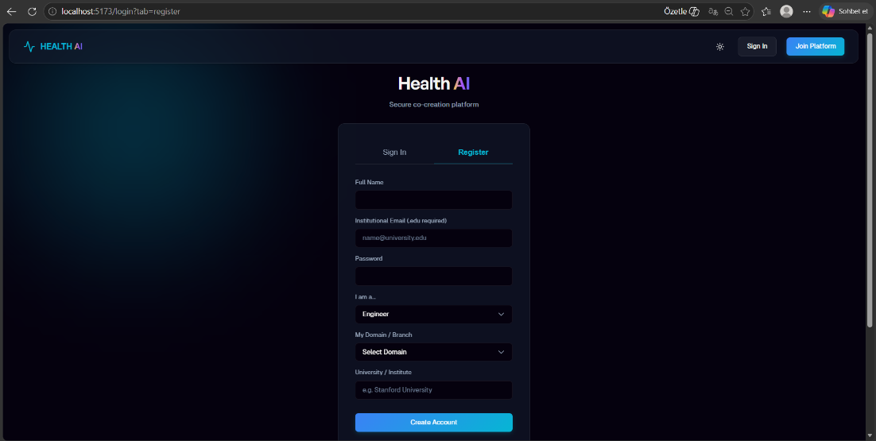
2 | Click the “Register” button on the homepage.
3 | Enter your institutional .edu email address and choose a strong password.
4 | Select your role: Engineer or Healthcare Professional. | 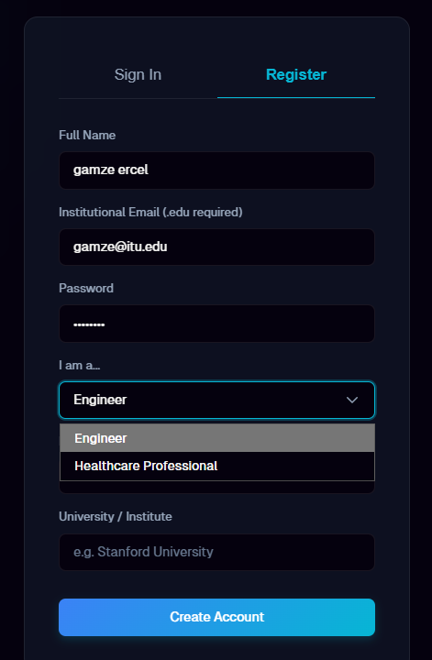
5 | Select Domain/Branch | 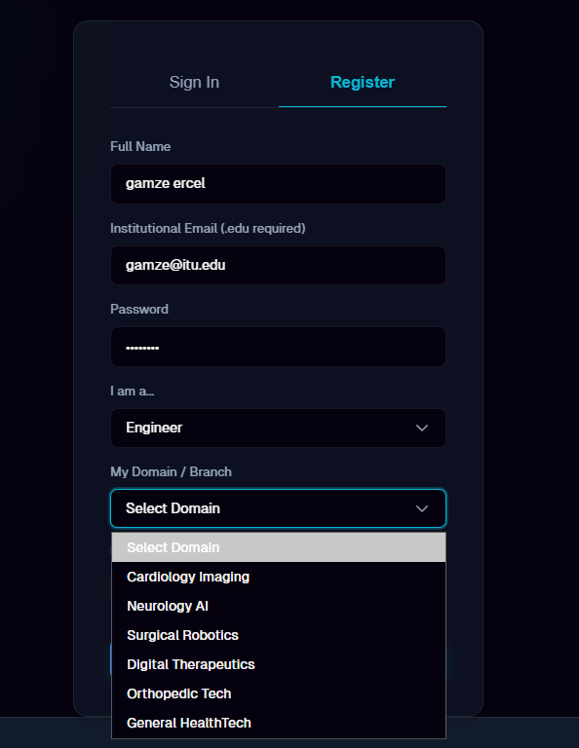

2.2 Login
Step | Description | Screenshot
1 | Navigate to the HEALTH AI platform URL. | 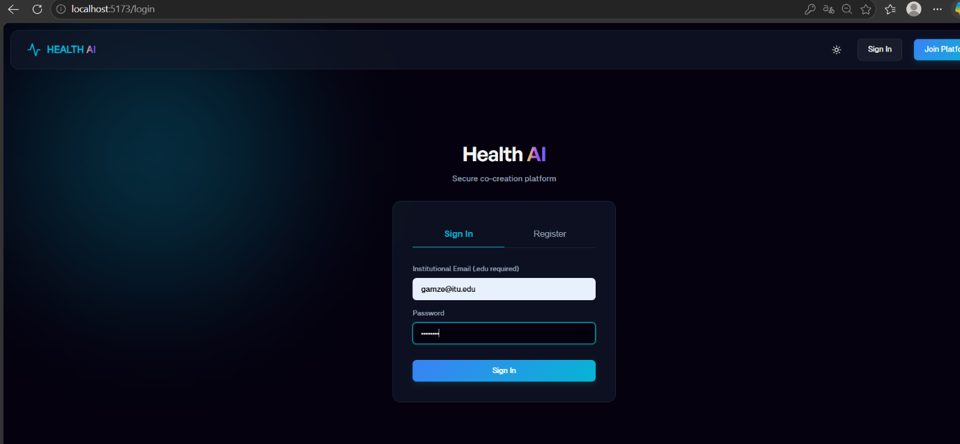
2 | Enter your email address and password.
3 | Click “Login”. You will be redirected to your Dashboard.

2.3 Dashboard Overview

After login, users see:

Navigation menu

Post feed

Notifications

Profile section

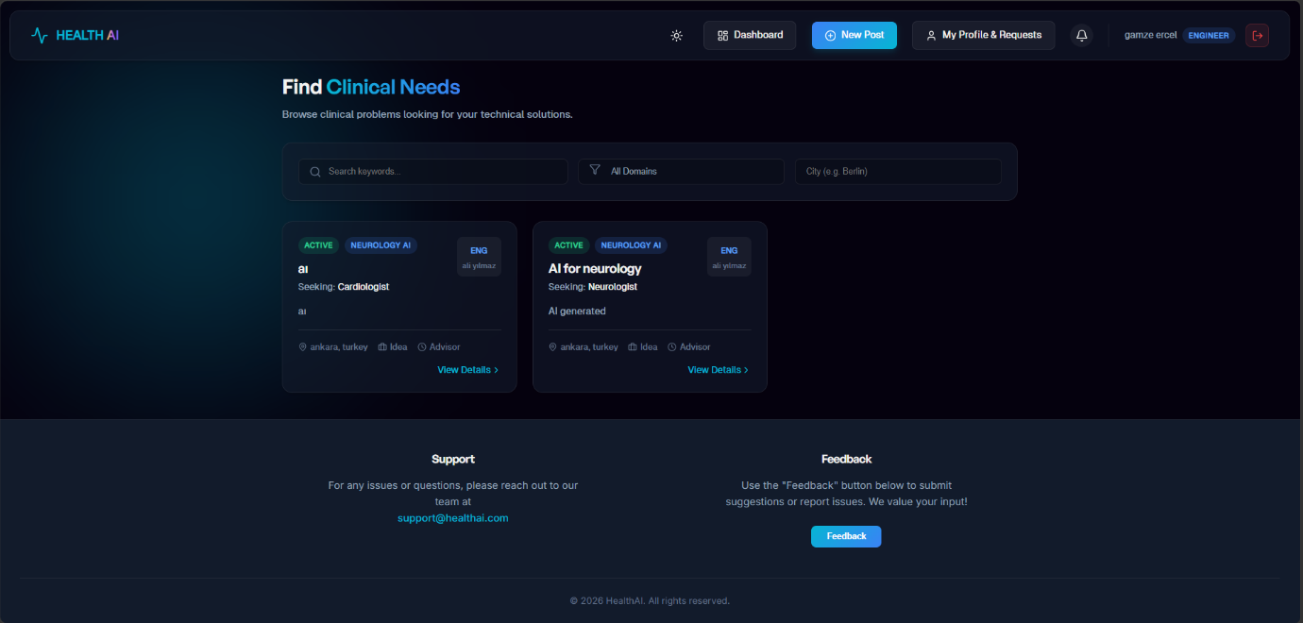

3. Post Management

3.1 Creating a New Post
Step | Description | Screenshot
1 | Click the “New Post” button on the Dashboard. | 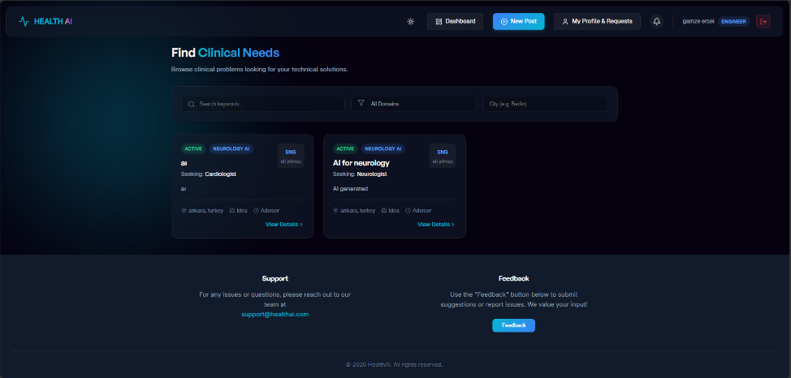
2 | Fill in all required fields in the post creation form (see field guide below). | 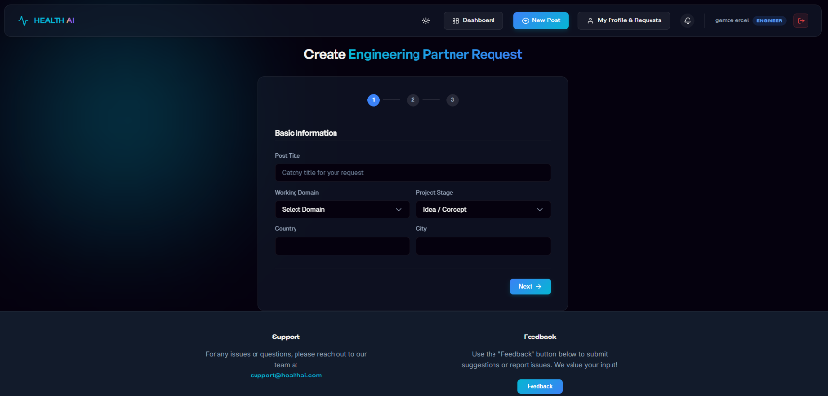
3 | Choose whether to save as Draft or Publish immediately. | 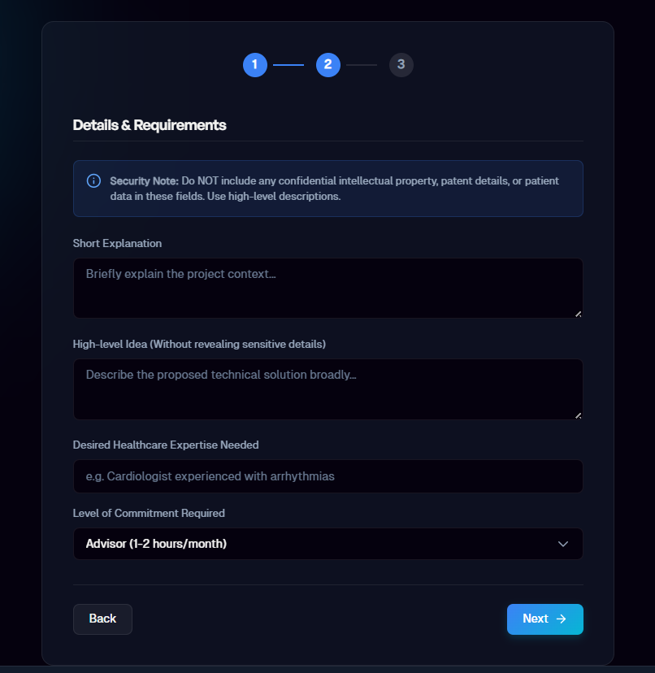
4 | Click “Save” or “Publish”. | 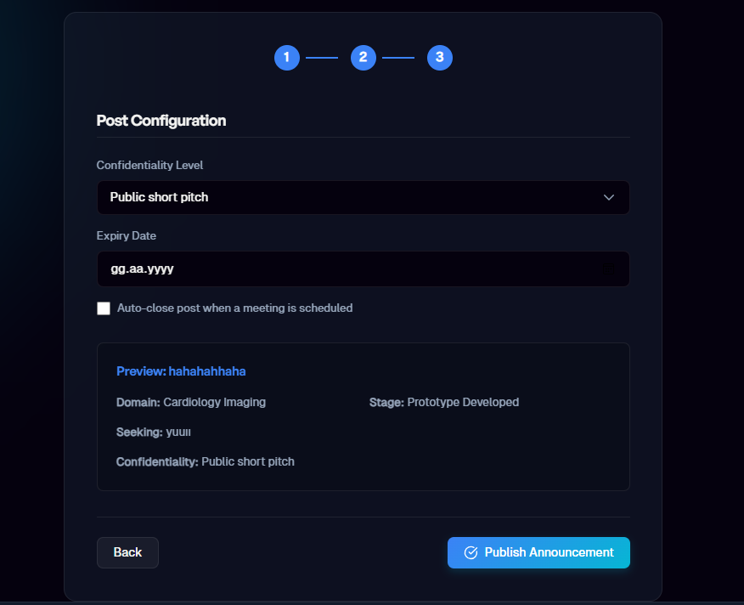
5 | Your post will appear on the Dashboard with the appropriate status. | 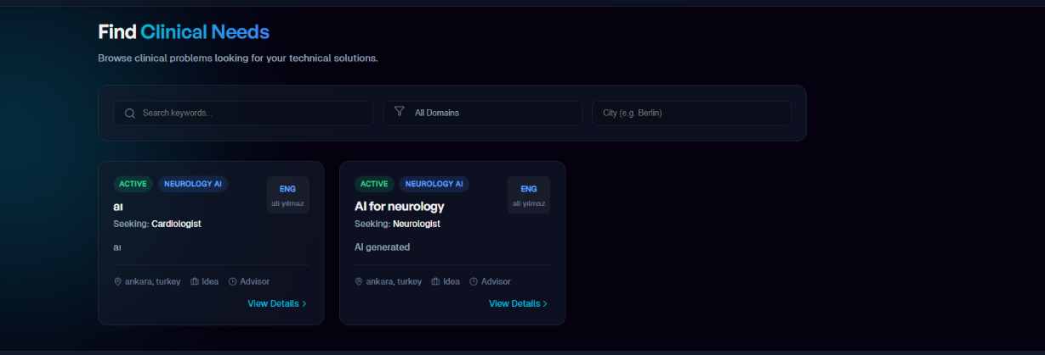

3.2 Post Form Fields
Field | Description | Example
Title | A clear and descriptive title for your collaboration post | "AI-Assisted Cardiology Diagnosis"
Working Domain | The medical or engineering domain of the project | Cardiology, Radiology, Orthopedics
Required Expertise | The type of expertise you are looking for in a partner | "Machine Learning Engineer"
Project Stage | Current stage of the project | Idea / Prototype / Research
Confidentiality Level | How sensitive is the project content? | Public / Confidential
City | Your location for city-based matching | Ankara, Istanbul, Izmir
Description | Detailed description of the collaboration opportunity | [Free text]

3.3 Editing a Post
Step | Description | Screenshot
1 | Navigate to your post (from Dashboard or “My Posts”). | 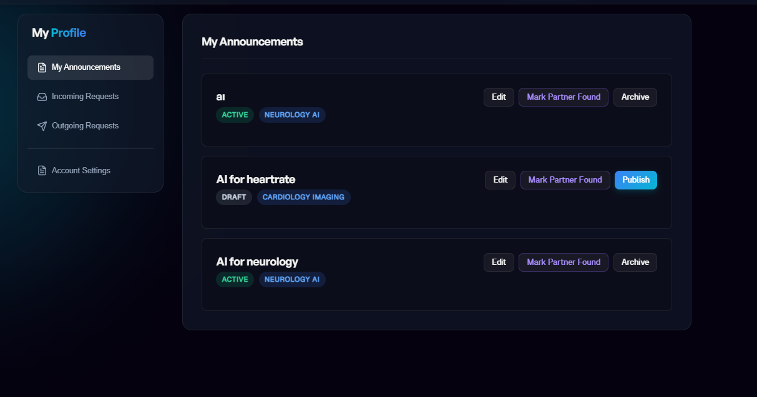
2 | Click the “Edit” button.
3 | Modify the desired fields and click “Save”. | 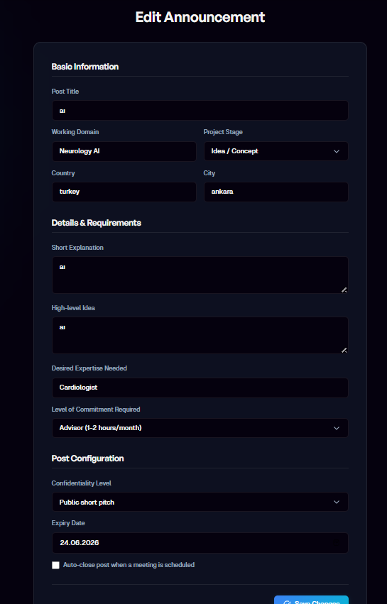

3.4 Post Status Guide
Explain each post status and what it means for the user.
Status | Meaning | Visual Indicator
Draft | Post is saved but not visible to other users | [Gray badge]
Active | Post is published and visible. Other users can express interest. | [Green badge]
Meeting Scheduled | A meeting has been scheduled with an interested partner | [Blue badge]
Partner Found | A collaboration partner has been found. Post is closed. | [Purple badge]
Expired | Post has expired due to inactivity or time limit | [Red badge]

3.5 Marking Partner Found
Step | Description | Screenshot
1 | Open the post for which you found a partner. | 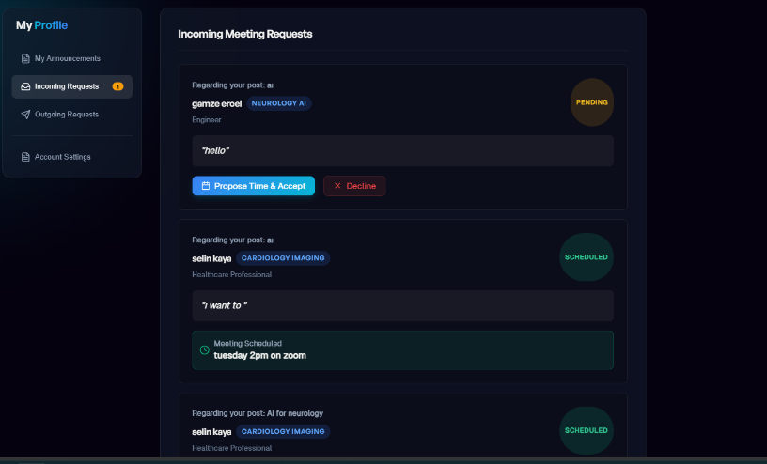
2 | Click the “Mark as Partner Found” button. | 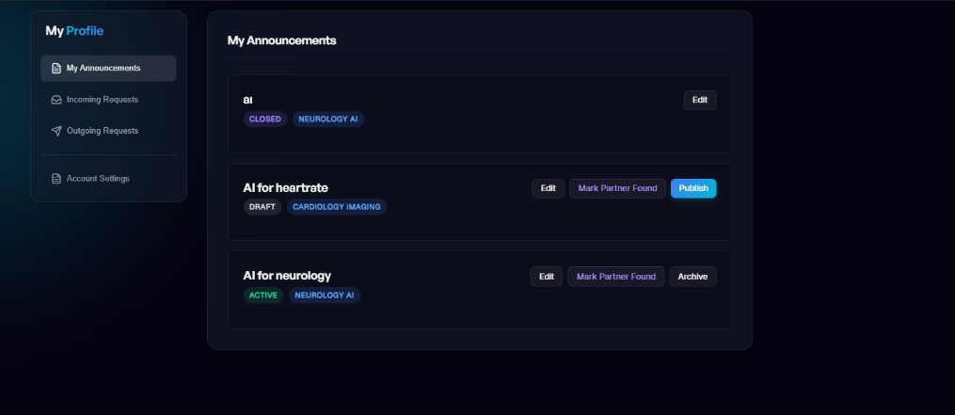
3 | Confirm the action. The post status will change to “Partner Found” and will no longer accept new interest.

4. Search & Partner Discovery

4.1 Browsing Posts

Users scroll through posts and open details.

4.2 Filtering Options

Filter | Description
Domain | Filter by medical or engineering domain (e.g., Cardiology, AI, Biomedical)
City | Filter by location for city-based matching
Status | Show only Active, Draft (own posts), or all statuses
Required Expertise | Filter by the type of expertise being sought

4.3 City-Based Matching

Users are matched based on location.

5. Meeting Request Process

5.1 Expressing Interest
Step | Description | Screenshot
1 | Open the post detail page of a post you are interested in. | 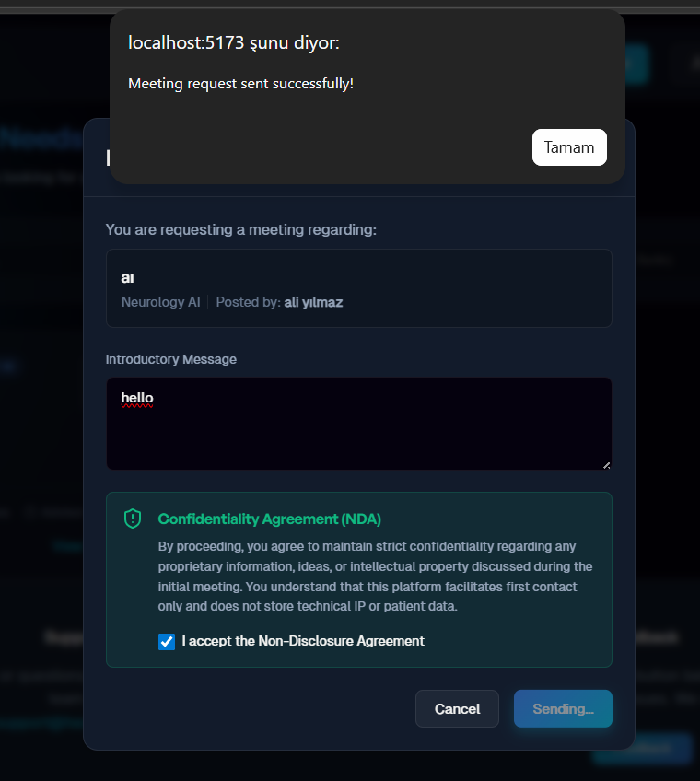
2 | Click the “Express Interest” or “Request Meeting” button.
3 | Optionally add a message explaining your interest and relevant experience. | [Insert screenshot]

5.2 NDA Acceptance

User must accept NDA before meeting.

5.3 Proposing & Accepting Time Slots
Step | Description | Screenshot
1 | Propose available time slots for the meeting (date and time). | 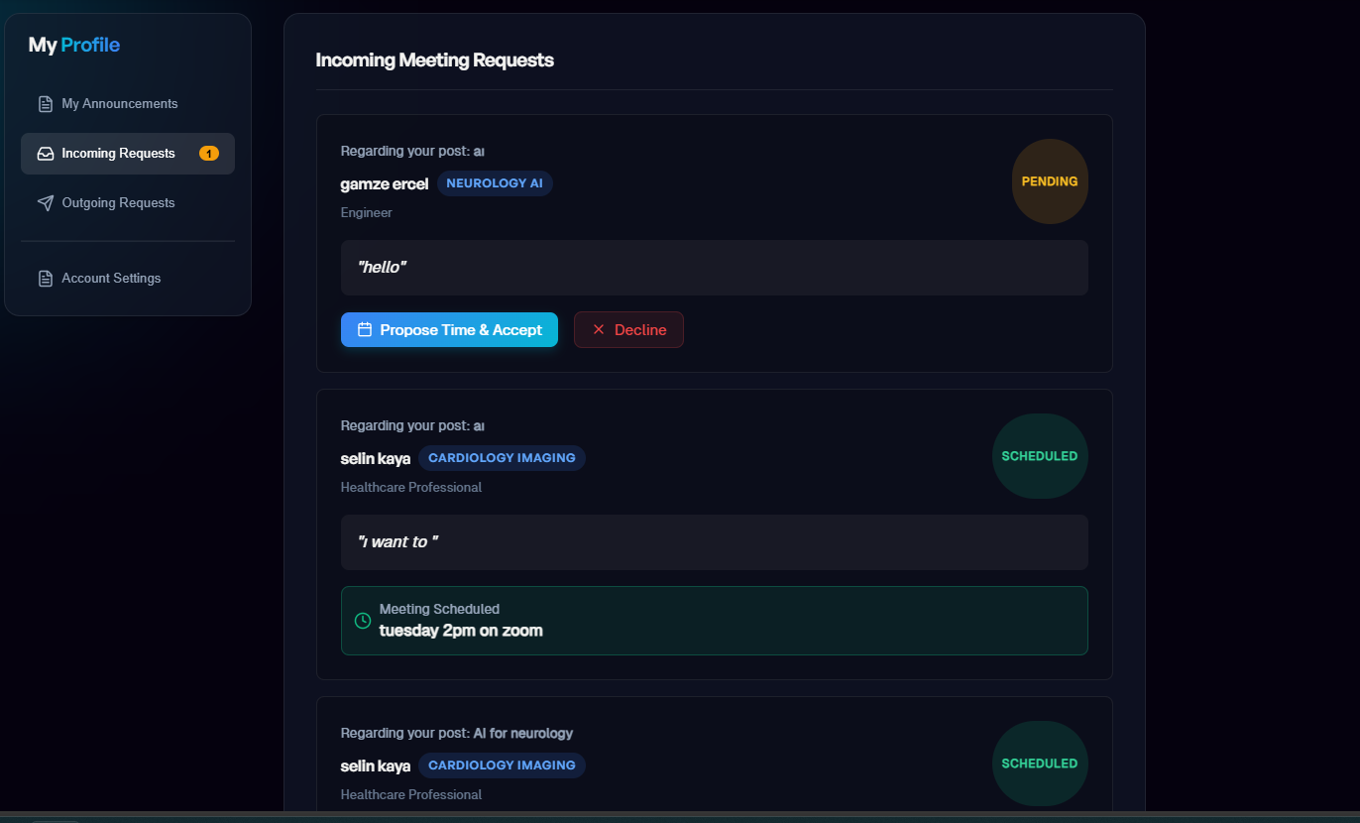
2 | The post owner reviews proposed slots and accepts one. | 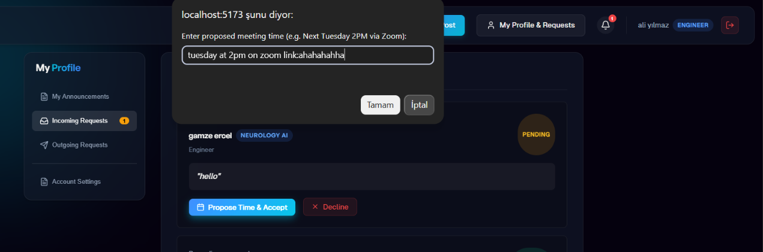
3 | Both parties receive a confirmation notification with the scheduled meeting time. | 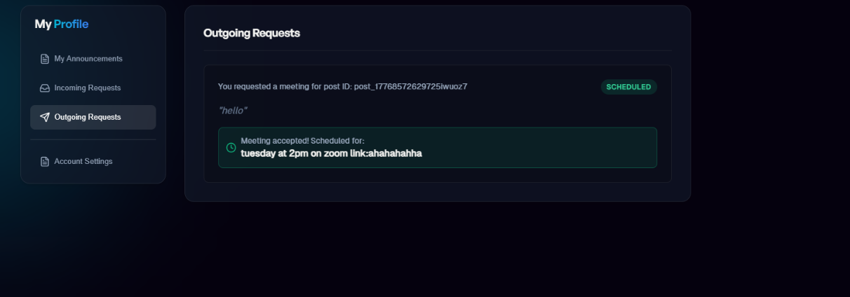
Note: Meetings take place externally (Zoom, Teams, etc.). The platform does not host meetings.

5.4 After the Meeting

Post owner can mark partner found.

6. Profile Management

6.1 Editing Your Profile
Users can update personal info.

6.2 Deleting Your Account (GDPR)
Step | Description | Screenshot
1 | Navigate to Profile Settings. | 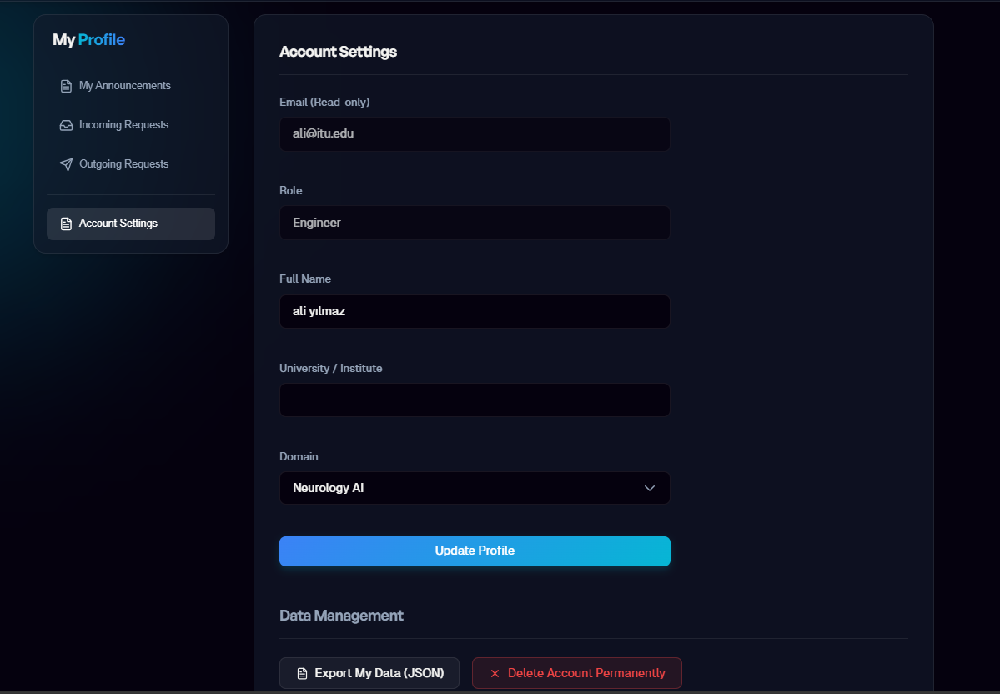
2 | Click “Delete Account”.
3 | Read the warning about permanent data deletion.
4 | Confirm by entering your password.
5 | Your account and all associated data will be permanently deleted.
Under GDPR, users have the right to request complete deletion of their personal data.

6.3 Exporting Your Data

Users can download their data.

7. Admin Panel
This section is only available to users with the Admin role.

7.1 Post Management

Step | Description | Screenshot
1 | Navigate to Admin Panel → Posts. | 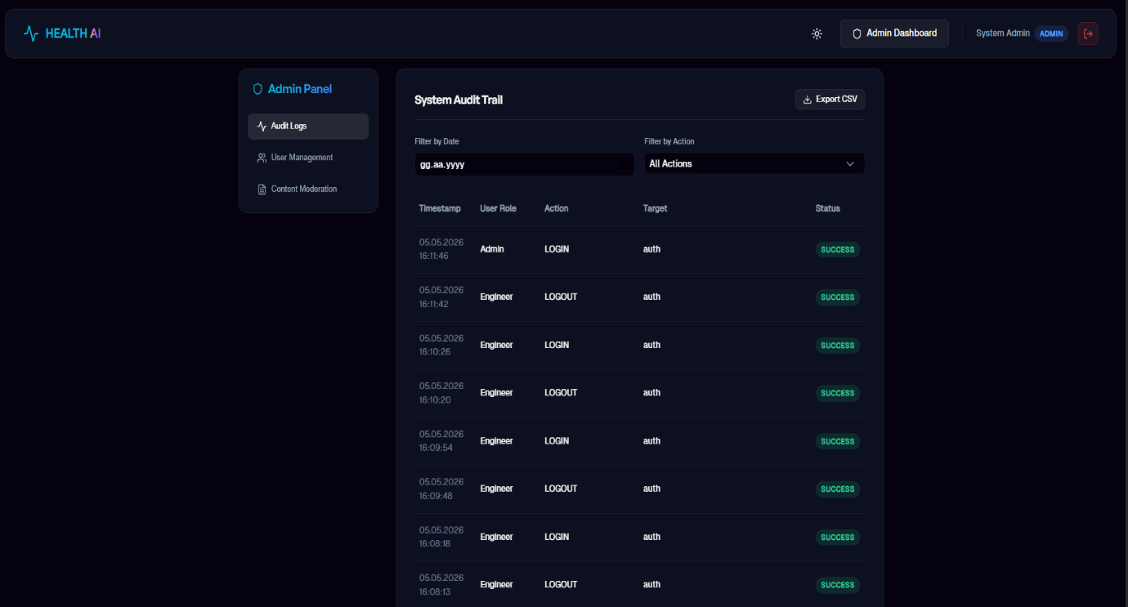
2 | Browse or filter posts by status, domain, or date.
3 | Click on a post to view details.
4 | Use the “Remove Post” button to remove inappropriate content.

7.2 User Management

Step | Description | Screenshot
1 | Navigate to Admin Panel → Users. | 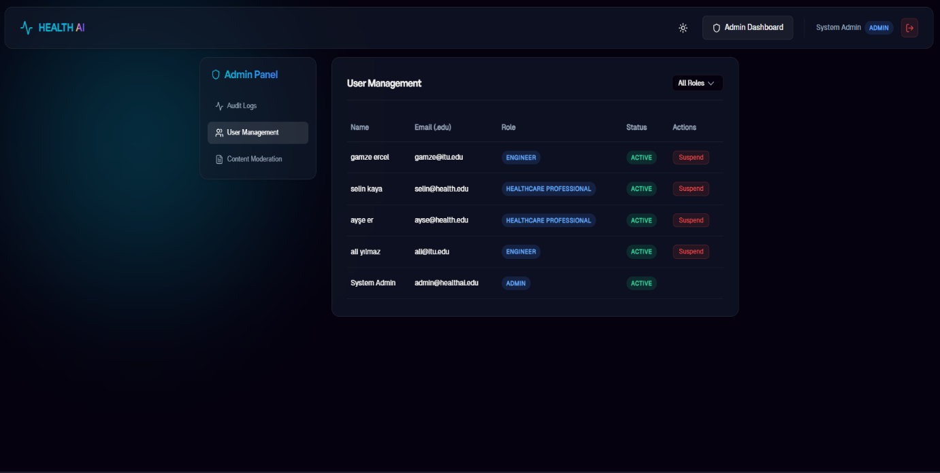
2 | Browse or filter users by role, status, or registration date.
3 | Click on a user to view their profile and activity.
4 | Use “Suspend Account” if needed.

7.3 Activity Logs & Statistics

Step | Description | Screenshot
1 | Navigate to Admin Panel → Logs. | 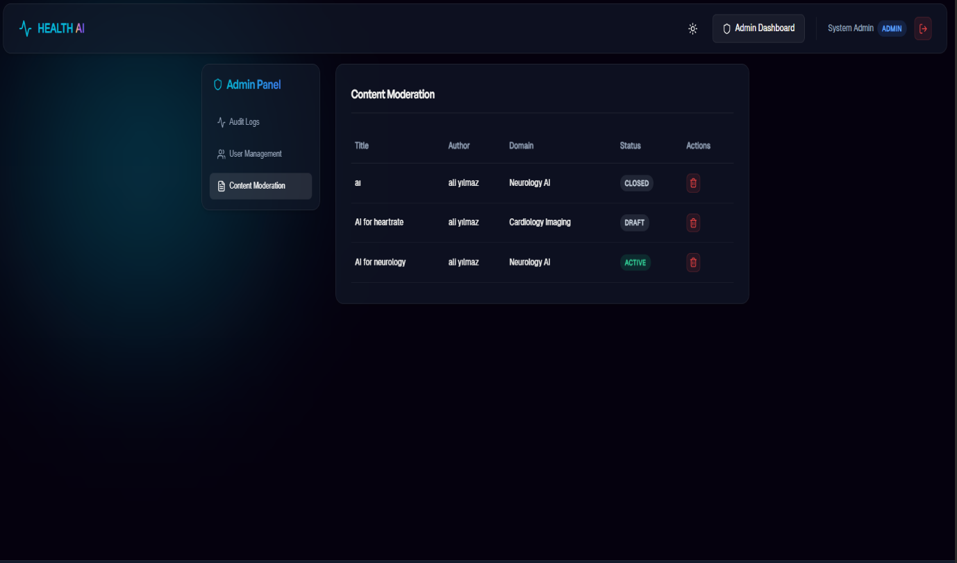
2 | Use filters to narrow down logs (date range, user, action type).
3 | Review the log entries in the table.
4 | Click “Export CSV” to download the filtered logs.

8. Notifications

Notification Type | Description | Channel
Interest Received | Someone expressed interest in your post | [Email / In-App]
Meeting Request | A meeting request has been sent or received | [Email / In-App]
Meeting Confirmed | A meeting time has been accepted by both parties | [Email / In-App]
Post Status Changed | A post you’re involved with changed status | [In-App]
Account Activity | Login from new device, password change, etc. | [Email]
[Add more] | [...] | [...]

9. Frequently Asked Questions (FAQ)
Question | Answer
My .edu email is not accepted. What should I do? | Ensure you are using an institutional email with a .edu or .edu.tr extension. If the issue persists, contact support.
I didn’t receive the verification email. | Check your spam/junk folder. You can also click “Resend Verification Email” on the login page.
Can I edit a published post? | Yes, you can edit your post at any time while it is in Draft or Active status.
How do I delete my account and data? | Go to Profile Settings → Delete Account. This action is permanent and cannot be undone.
Are meetings held on the platform? | No. Meetings are conducted on external platforms (Zoom, Teams, etc.). The platform only facilitates scheduling.
Can I have multiple active posts? | [Describe the policy on multiple concurrent posts]
[Add more questions] | [Add answers]

10. Troubleshooting
Problem | Possible Cause | Solution
Page is not loading | Internet connection issue or server downtime | Check your connection. Try refreshing the page. If the issue persists, try again later.
Session closed unexpectedly | Session timeout or browser cookie issue | Log in again. Enable cookies in your browser settings.
Filters return no results | No posts match the selected criteria | Try broader filter settings or remove some filters.
Cannot submit meeting request | Post may have been closed or you haven’t accepted the NDA | Refresh the post page and check the NDA acceptance step.
[Add more] | [...] | [...]

11. Contact & Support
Channel | Details
Email | support@healthai.com
In-Platform Feedback | Use the “Feedback” button in the footer to submit suggestions or report issues.

12.Extra
Light/Dark mode supported. Toggle between Light and Dark mode using the sun and moon icons at the top.
